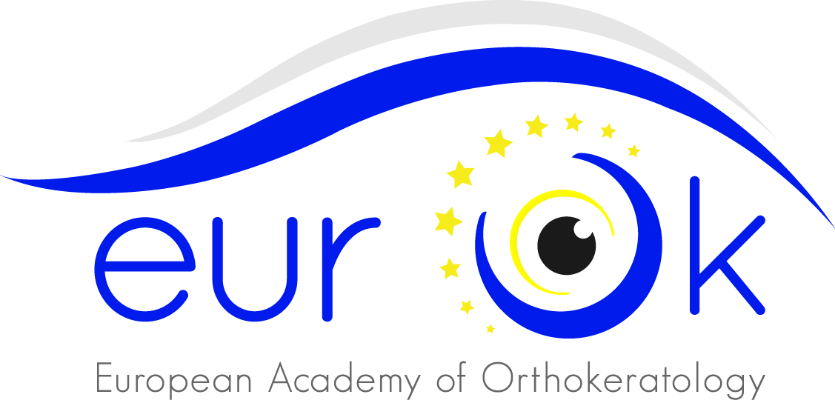

**European Academy of Orthokeratology**

Via Buccari,1 – 30171 - Venezia (Italy)

E-mail: [info@orthokeratology.eu](mailto:info@orthokeratology.eu)

Fax: +39 041 8872145

***To EurOK’s members***

***To EurOK’s Board of Directors***

*EurOK’s President*

**Hereby convene the European Academy of Orthokeratology Assembly Meeting**

To be held on Saturday, June 28th at 23,15 and **Sunday, June 29th at 18,00 on second call**

At **Novotel Bologna Fiera**

Via Michelino 73, 40127 Bologna, Italy

***With the following Agenda:***

1. Opening, verifying quorum and appointing the working panel of the Assembly
2. Presentation of the 2013 annual report by EurOK’s Secretary.
3. Amendments to actual By-law
4. Any other business

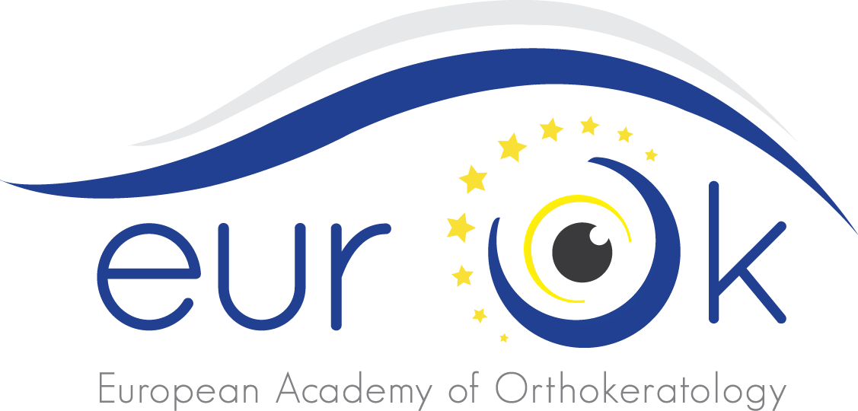Venice, May 20th 2014

***EurOK President***

*MarinMarino Formenti*



**DELEGATION\***

I hereby wish to delegate Mr/Dr       to represent myself at the cited Assembly.

Date:

Printed name:

Signed: ________________________

(* Every member present to the assembly can represent by delegation no more than 2 members)